**Ensemble Deep Learning:** 

**Neural Networks** 

***Rhiannon Hicks*** - REU Correspondent

*Dr. Mihhail Berezovski* - REU Program Director

Embry-Riddle Aeronautical University

*Dr. Jesse Adams* and *Dr. Margaret Lund* - Senior Scientists Nevada National Security Site 

*Support for the program has been provided by the National Science Foundation (NSF) through REU Award Number DMS - 2050754.*

**Background**

**Why Neural Networks?**

**Why is this**

**important?**

Improved error quantification More accurate analysis Safer United States

**Absorption Spectroscopy Data for Metal Oxides**

Image Size: (64, 64, 3, 180902) 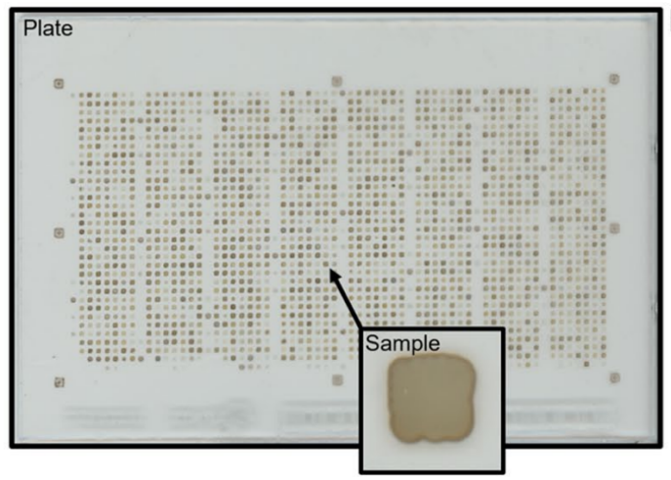

Channels: R, G, & B

Normalized: 0-1 for every

channel

Stein, H. S., Soedarmadji, E., Newhouse, P. F., Guevarra, D. & Gregoire, J. M.

Synthesis, optical imaging, and absorption spectroscopy data for 179072 metal

oxides. Fgshare https://doi.org/10.6084/m9.fgshare.7502207 (2019).

**Data Continued...**

Initial image data (input) Absorption spectra (output)

**Initial Strategy**

**CREATE** 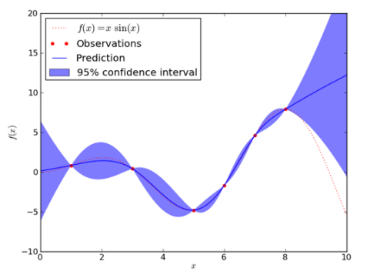

**NEURAL**

**NETWORK**

**BUILD** 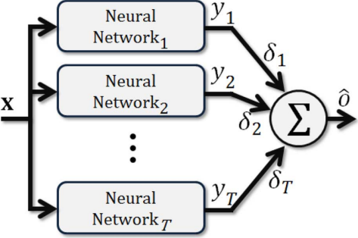

**ENSEMBLE**

**IMPLEMENT**

**UNCERTAINTY**

**QUANTIFICATION**

**Initial Results**

**Layers Used:**

**Epochs:** 50

- initial attempt at neural networkConvolutional 1.

**Batch Size:** 32

2.

3. 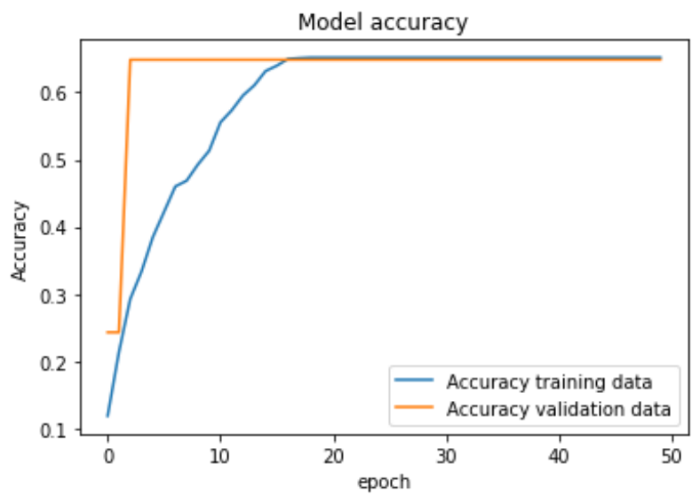

4.

5.

6.

7.

8.

9.

10. 11. 12. 13.

Dense

Max Pooling Convolutional Dense

Max Pooling Convolutional Convolutional Max Pooling Flatten

Dense

Dense

Dense

**Images:** 10,000 **Networks:** 1

**Initial Results Cont.** - improving upon neural network

**Layers Used:**

**Epochs:** 50

1. 2. 3. 4. 5. 6. 7. 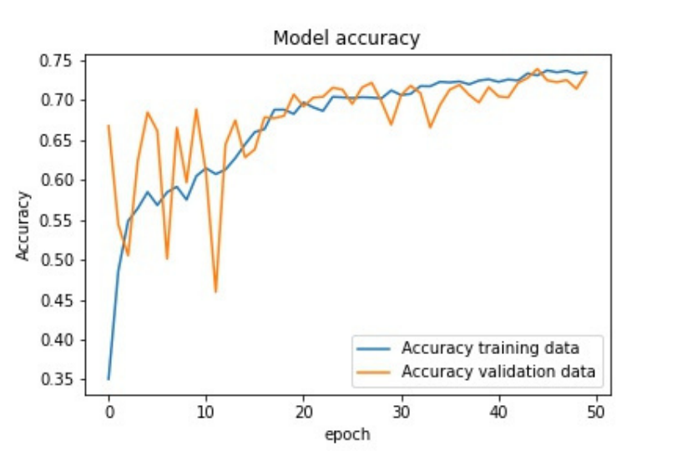

Convolutional Dense

Max Pooling Flatten

Dense

Dense

Dense

**Batch Size:** 32 **Images:** 10,000 **Networks:** 1

**Initial Results Cont.** - initial ensemble effect on individual graphs

1 Network

5 Networks

**Initial Results Cont.**

**Insights:**

- Changing the architecture greatly impacted the predictions - Adding an ensemble improved the predictions, but had oscillations

**Improvements:**

- Look at each individual network's performance

- Prevent overtraining of the data

- Have uncertainty quantification

**Final Results**

**Summary:**

- Add dropout layer

- Increase number of images

- Add early stopping

**Epochs:** Early Stopping

**Batch Size:** 32

**Networks:** 1

**Images:** 40,000

**Final Results Cont.**

**Summary:**

- Add binning/bucketing

**Epochs:** Early Stopping

**Batch Size:** 32

**Networks:** 1

**Images:** 40,000

**Final Results Cont.**

**Summary:**

- Increase number of networks

**Epochs:** Early Stopping

**Batch Size:** 32

**Networks:** 10

**Images:** 40,000

**Uncertainty Quantification**

Mean Squared Error

Linear Regression Model

Confidence Interval

Accuracy Prediction Model

**Mean Squared Error**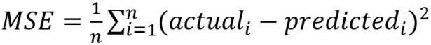

**Linear Regression Model**

**R^2:** 0.64518

**Yellow:** Average of Blue

**Blue:** All network predictions

**Confidence Interval**

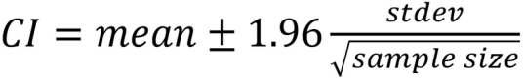

Standard Deviation

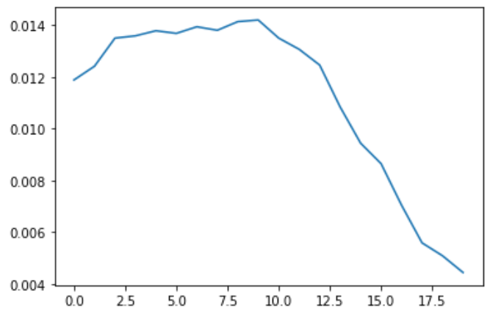

**Accuracy**

**Prediction Model How it works:**

1. 2. 3.

Determine how many points fall within the 95% confidence interval

Divide this by the total

number of points to get a percentage

Percentage represents how accurate the model is

**Key Conclusions**

By using a confidence interval, an accuracy measurement of the model can be determined

The neural network for this dataset was not successful since the accuracy measurement was very low

There are limitations on this dataset and model due to available ram and time constraints

Q U E S T I O N S ?

*Rhiannon Hicks* - hicksr10@my.erau.edu

*Mihhail Berezovski* - berezovm@erau.edu